

**LSPU Quality Assurance**

Compilation of **Minutes of the Meeting**

(January to September 2021)

# **Prepared by:**

Office of the Vice President for Academic Affairs September 2021

Republic of the Philippines



# Laguna State Polytechnic University

Province of Laguna

**Contents**

|  |  |  |
| --- | --- | --- |
| **Date**  **(2021)** | **Council/Campus** | **Concerns** |
| August 4 | Internal Quality Auditors | * ISO 2nd Follow Up Remote Audit Report * Review of LSPU-LCP * Activities and Timeline * ISO Recertification Preparation |
| September 3 | Internal Quality Auditors | * Presentation and Approval of the Minutes of the Previous Meeting * Reschedule of ISO Activities and Timeline * Updating of Risk Register * Updating of Office Performance Committee and Review (OPCR) |

Quality Assurance Minutes of the Meeting 2021 (January to September 2021)



## INTERNAL QUALITY AUDITORS

1. **(Process Owners)**

3 **__________________________________________________________________________________________________________**

4

## MINUTES OF THE QUALITY MANAGEMENT REPRESENTATIVES (TOP MANAGEMENT),

1. **INTERNAL QUALITY AUDITORS, AND PROCESS OWNERS MEETING HELD VIA ZOOM ON**

7 **AUGUST 4, 2020, 9:00AM**

8 **__________________________________________________________________________________________________________**

9

10 **PRESENT**

11

1. Top Management
2. *Vice President*
3. DR. EDEN C. CALLO Academic Affairs
4. DR. ROBERT C. AGATEP Research and Development

16

1. *Campus Director*
2. ENGR. MANUEL LUIS ALVAREZ Sta. Cruz Campus
3. JOEL M. BAWICA Los Baños Campus

20

21 Internal Quality Auditors and Process Owners

22

1. *Academic Officials and Staff*
2. *Dean*
3. DR. EDITHA R. PEREY College of Agriculture
4. DR. RICHARD C. AMPO College of Arts and Sciences
5. MARYJANE D. FUENTES College of Business Management
6. and Accountancy
7. JEFFERSON L. LERIOS College of Computer Studies
8. ENGR. JONNEL K. PABICO College of Engineering
9. JOSELITO S. MIRANDA College of Fisheries
10. CHARMINE V. RIVERA College of Hospitality Management
11. and Tourism
12. DR. FREDDIE S. PINUELA College of Industrial Technology
13. DR. FLORHAIDA V. PAMATMAT College of Teacher Education

36

37 *Associate Dean*

38

1. *College of Arts and Sciences*
2. DR. JULIE FE D. PANOY San Pablo City Campus
3. JEROME S. NICOLAS Los Baños Campus

42

1. *College of Business Management*
2. *and Accountancy*
3. GRACE M. ESMADE Siniloan Campus

46

47

48

|  |  |  |
| --- | --- | --- |
| 1 |  | *College of Computer Studies* |
| 2 | REYNALEN JUSTO | Sta. Cruz Campus |
| 3 | ARCHIEVAL M. JAIN | Siniloan Campus |
| 4 | RONNEL A. DELA CRUZ | San Pablo City Campus |
| 5 |  |  |
| 6 |  | *College of Criminal Justice Education* |
| 7 | MARK LITO L. REFUGIA | Sta. Cruz Campus |
| 8 | WILFREDO D. DALUGDOG | Siniloan Campus |
| 9 |  |  |
| 10 |  | *College of Engineering* |
| 11 | ENGR. MENCHIE DEL ROSARIO | Siniloan Campus |
| 12 | ENGR. PAUL ENRICO F. PUYO | San Pablo City Campus |
| 13 |  |  |
| 14 |  | *College of Hospitality Management* |
| 15 |  | *and Tourism* |
| 16 | DR. NINEVETCH GRACE O. MARCO | San Pablo City Campus |
| 17 | SHARON RAMOS | Los Baños Campus |
| 18 |  |  |
| 19 |  | *College of Industrial Technology* |
| 20 | EUDORA C. TABO | San Pablo City Campus |
| 21 |  |  |
| 22 |  | *College of Teacher Education* |
| 23 | DR. ELAINE ROSE G. NACHON | Siniloan Campus |
| 24 | DR. EDILBERTO Z. ANDAL | San Pablo City Campus |
| 25 | DR. KAREN MANAIG | Los Baños Campus |
| 26 |  |  |
| 27 |  | *Program Coordinator* |
| 28 | FLOREIZL P. VENTOCILLA | College of Industrial Technology |
| 29 |  | San Pablo City Campus |
| 30 |  |  |
| 31 | KRISTELLE ANN R. TORRES | Instructor |
| 32 |  |  |
| 33 | *Administrative Officials and Staff* |  |
| 34 |  | *Director* |
| 35 | GREG R. REYES | Admission and Registrarship |
| 36 | MARY GRACE P. GALLARDO | Alumni and Placement Services |
| 37 | MARIE AMMABELLE I. CABILDO | Budget and Finance Services |
| 38 | LIBERATA A. CAPILOS | Business Affairs Office |
| 39 | ANGELA L. REGINALDO | Extension and Training Services |
| 40 | DR. RUBY B. BRION | Gender and Development |
| 41 | EDWARD S. FLORES | Information and Communication |
| 42 |  | Technology Services |
| 43 | MARIA LIRIO C. RAGEL | Human Resource Management |
| 44 | HOSEAL B. GAYMAN | Library Services |
| 45 | ENGR. RANIEL LOUIE W. MENDIOLA | Management Information System |
| 46 | DANILO N. DARAN | Physical Plant and Site Development |
| 47 | DR. ALBERTO D. YAZON | Quality Assurance |
| 48 | GREG R. YEYES | Registrar |

|  |  |  |
| --- | --- | --- |
| 1 | DR. MICHELLE B. SARMIENTO | Student Affairs Services |
| 2 | SANDY JESSIE LYNN B. LEOBRERA | Student Financial Assistance |
| 3 | ROLANDO S. MAGLAPUZ | Security Management Office |
| 4 |  |  |
| 5 |  | *Chairperson* |
| 6 |  |  |
| 7 |  | *Admission and Registrarship* |
| 8 | MA. GRACIELLA C. PRADILLADA | Siniloan Campus |
| 9 |  |  |
| 10 |  | *Alumni Affairs and Placement Services* |
| 11 | ROGACION U. VILLANUEVA | Siniloan Campus |
| 12 | JENNELYN E. ESPINUEVA | San Pablo City Campus |
| 13 |  |  |
| 14 |  | *Budget and Finances* |
| 15 | MARIBEL P. LAT | San Pablo City Campus |
| 16 |  |  |
| 17 |  | *Business Affairs Office* |
| 18 | ROWENA A. NAGA | Sta. Cruz Campus |
| 19 | NIKKO LEE L. DANDAN | Los Baños Campus |
| 20 |  |  |
| 21 |  | *Curriculum and Instruction* |
| 22 |  | *and Development* |
| 23 | DR. VILMA M. GERONIMO | Sta. Cruz Campus |
| 24 | ALLEN PASIA | San Pablo City Campus |
| 25 | SHERWIN B. SAPIN | Los Baños Campus |
| 26 |  |  |
| 27 |  | *Extension and Training Services* |
| 28 | AIMEE CONCEPCION CHAVEZ | Siniloan Campus |
| 29 |  |  |
| 30 |  | *Gender and Development* |
| 31 | MARY ANN S. HERNANDEZ | Los Baños Campus |
| 32 |  |  |
| 33 |  | *Guidance Services* |
| 34 | ABIGAIL O. VIAR | Sta. Cruz Campus |
| 35 | NOEMI B. NUÑES | Los Baños Campus |
| 36 |  |  |
| 37 |  | *Human Resource Management* |
| 38 | ANNALIZA B. DE ROMA | San Pablo City Campus |
| 39 | EFREN R. DELA PAZ, JD | Los Baños Campus |
| 40 |  |  |
| 41 |  | *Information and Communications* |
| 42 |  | *Technology Services* |
| 43 | NEIRRO C. ILAGAN | San Pablo City Campus |
| 44 | LOYD S. ECHALAR | Los Baños Campus |
| 45 |  |  |
| 46 |  | *International and Local Affairs* |
| 47 | CELESTE CASTILLO MARQUEZ | Sta. Cruz Campus |
| 48 |  |  |

|  |  |  |
| --- | --- | --- |
| 1 |  | *Library Services* |
| 2 | AILEEN R. GAYMAN | Siniloan Campus |
| 3 | MARIA NINA GRACE C. PASTORFIDE | San Pablo City Campus |
| 4 | JOSEPH VILLIMORE D. GERONIMO | Los Baños Campus |
| 5 |  |  |
| 6 |  | *Management Information System* |
| 7 | ENGR. NEIL JAMES P. NOVAL | San Pablo City Campus |
| 8 |  |  |
| 9 |  | *Planning and Development* |
| 10 | ENGR. MARICEL M. MATUTO | Sta. Cruz Campus |
| 11 | JOHN FREDERICK B. TESORO | Los Baños |
| 12 | CLARITO H. GARCIA | San Pablo City Campus |
| 13 |  |  |
| 14 |  | *Quality Assurance* |
| 15 | DR. ENRICO R. RIVANO | Sta. Cruz Campus |
| 16 | ENGR. ROMMEL OCTAVIUS R. NUESTRO | Siniloan Campus |
| 17 | LORENA H. GARCIA | San Pablo City Campus |
| 18 |  |  |
| 19 |  | *Research and Development* |
| 20 | RINA J. ARCIGAL | Sta. Cruz Campus |
| 21 | DR. DELON A. CHING | San Pablo City Campus |
| 22 | OFELIA B. MANINGAS | Los Baños Campus |
| 23 |  |  |
| 24 |  | *Scholarship and Financial Assistance* |
| 25 | CHEEROBIE B. ARANAS | Sta. Cruz Campus |
| 26 | DR. AGRIPINA F. BANAYO | San Pablo City Campus |
| 27 | FLORA H. SALANDANAN | Los Baños Campus |
| 28 |  |  |
| 29 |  | *Senior High School* |
| 30 | JOHN VINCENT C. ALIZAS | San Pablo City Campus |
| 31 |  |  |
| 32 |  | *Sports Development* |
| 33 | DR. LIZA L. BARTOLOME | Sta. Cruz Campus |
| 34 |  |  |
| 35 |  | *Student Affairs and Services* |
| 36 | JAYSON N. OLAYTA | Siniloan Campus |
| 37 | ALBERTO B. CASTILLO | San Pablo City Campus |
| 38 |  |  |
| 39 |  | *Coordinator* |
| 40 | VICTORIA E. TAMBAN | Innovation and Technology Support Office |
| 41 |  |  |
| 42 | GIZELLE A. ALVAREZ | Accountant III |
| 43 | CHRISTIAN A. CALABIA | Administrative Aide V |
| 44 | SIEGFRIED S. CRUCILLO | University Nurse |
| 45 |  |  |
| 46 |  |  |
| 47 |  |  |
| 48 |  |  |

|  |  |  |
| --- | --- | --- |
| 1 | *Internal Quality Auditors* |  |
| 2 | TERESITA F. BUENO | Siniloan Campus |
| 3 | DR. ROLANDO R. CRUZADA | Siniloan Campus |
| 4 | CORNELIO R. MOLON | Siniloan Campus |
| 5 | FLAVIANO URERA JR. | Siniloan Campus |
| 6 | MARCO DEL ROSARIO JR. | San Pablo City Campus |
| 7 | CATHERINE A. CASTILLO | San Pablo City Campus |
| 8 | MARGARITA A. GALANG | Los Baños Campus |
| 9 | JEIROME P. DOMINGO | Los Baños Campus |
| 10 | ROSEMARIE A. MALAPAYA | Los Baños Campus |
| 11 | ROWAN E. ELOMINA | Los Baños Campus |
| 12 |  |  |
| 13 | *Process Owners* |  |
| 14 | CATALYN ROSE P. ANGELES | Sta. Cruz Campus |
| 15 | BRAINARD H. REYES | Sta. Cruz Campus |
| 16 | CLAUDETTE LUI M. REYES | Sta. Cruz Campus |
| 17 | MARYDEL V. BAYOCOT | Siniloan Campus |
| 18 | DULCE M. BITICON | Siniloan Campus |
| 19 | AURELIA M. CASTRO | Siniloan Campus |
| 20 | MA. CECILIA C. GATOBONTON | Siniloan Campus |
| 21 | LEONICIA A. MERCADO | Siniloan Campus |
| 22 | ROWENA D. SORIANO | Siniloan Campus |
| 23 | KAREN CHRIS B. LATADE | San Pablo City Campus |
| 24 | MAGDALENA P. GAFFUD | San Pablo City Campus |
| 25 | ANA DIGI FRANCISCO MERAÑA | San Pablo City Campus |
| 26 | CATHERINE S. SEMPIO | San Pablo City Campus |
| 27 | ELMA D. BAUTISTA | Los Baños Campus |
| 28 | MAY P. BELARMINO | Los Baños Campus |
| 29 | RACHELL CHAVEZ GALLNO | Los Baños Campus |
| 30 | MYRNA O. MEDRANO | Los Baños Campus |
| 31 | CARMELA JHOY G. MERCADO | Los Baños Campus |
| 32 | RICARDO F. WAGAN III | Los Baños Campus |
| 33 |  |  |
| 34 |  |  |
| 35 | KEVIN A. AMANTE | Technical Staff |

1. x x
2. The following accounts are the minutes of the meeting:

38

1. • *Preliminaries:* Engr. Rommel Octavius R. Nuestro, Chairperson for Quality Assurance
2. at the Siniloan Campus, served as the moderator of the event. For the preliminaries of
3. the meeting, Engr. Nuestro asked the Information and Communications Technology
4. Services (ICTS) personnel to play the audio-video presentations for the invocation,
5. national anthem, and university hymn.

44

1. • *Presentation of the Agenda.* Dr. Alberto D. Yazon, Director for Quality Assurance,
2. headed the meeting. Dr. Yazon welcomed the participants for the consultation
3. meeting, gave the objective of the meeting, and presented the agenda for the meeting,
4. namely: ISO 2nd Follow Up Remote Audit Report; Review of LSPU LCP; Activities and

1 Timeline, and ISO Recertification Preparation.

2

1. • *Results and Findings of the 2nd Follow up Remote Audit.* Dr. Yazon reviewed with the
2. body the positive findings, opportunities for improvements (OFI), minor non-
3. conformity, and recommendation from the external auditors.
4. The ten (10) positive findings noted by TUVRheinland are the following:

7

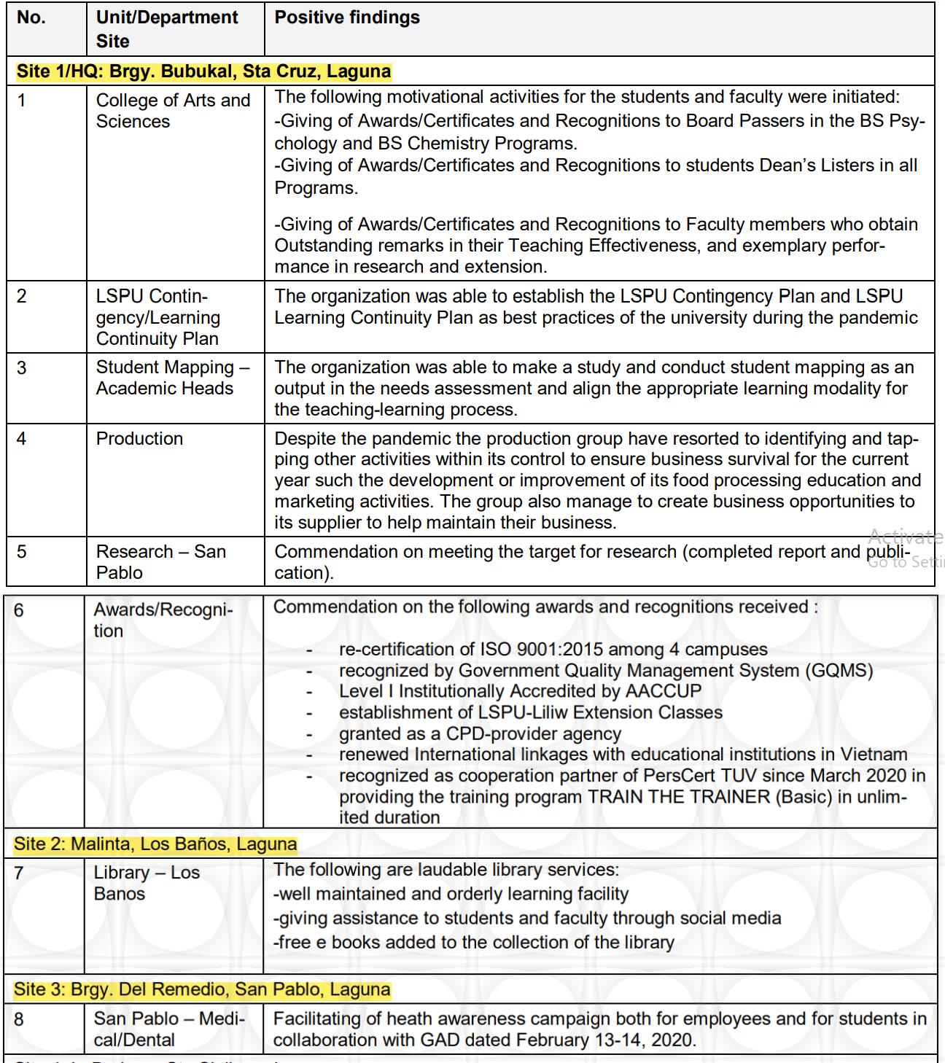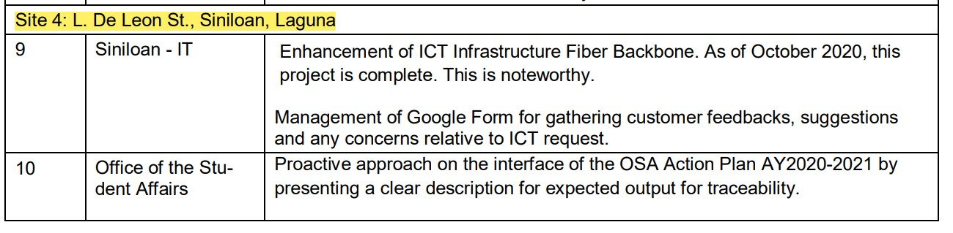

8

9

10

11

12 Meanwhile, there are twenty-two (22) opportunities for improvement (OFI)

1 identified by the external auditors. Some of these include:

2

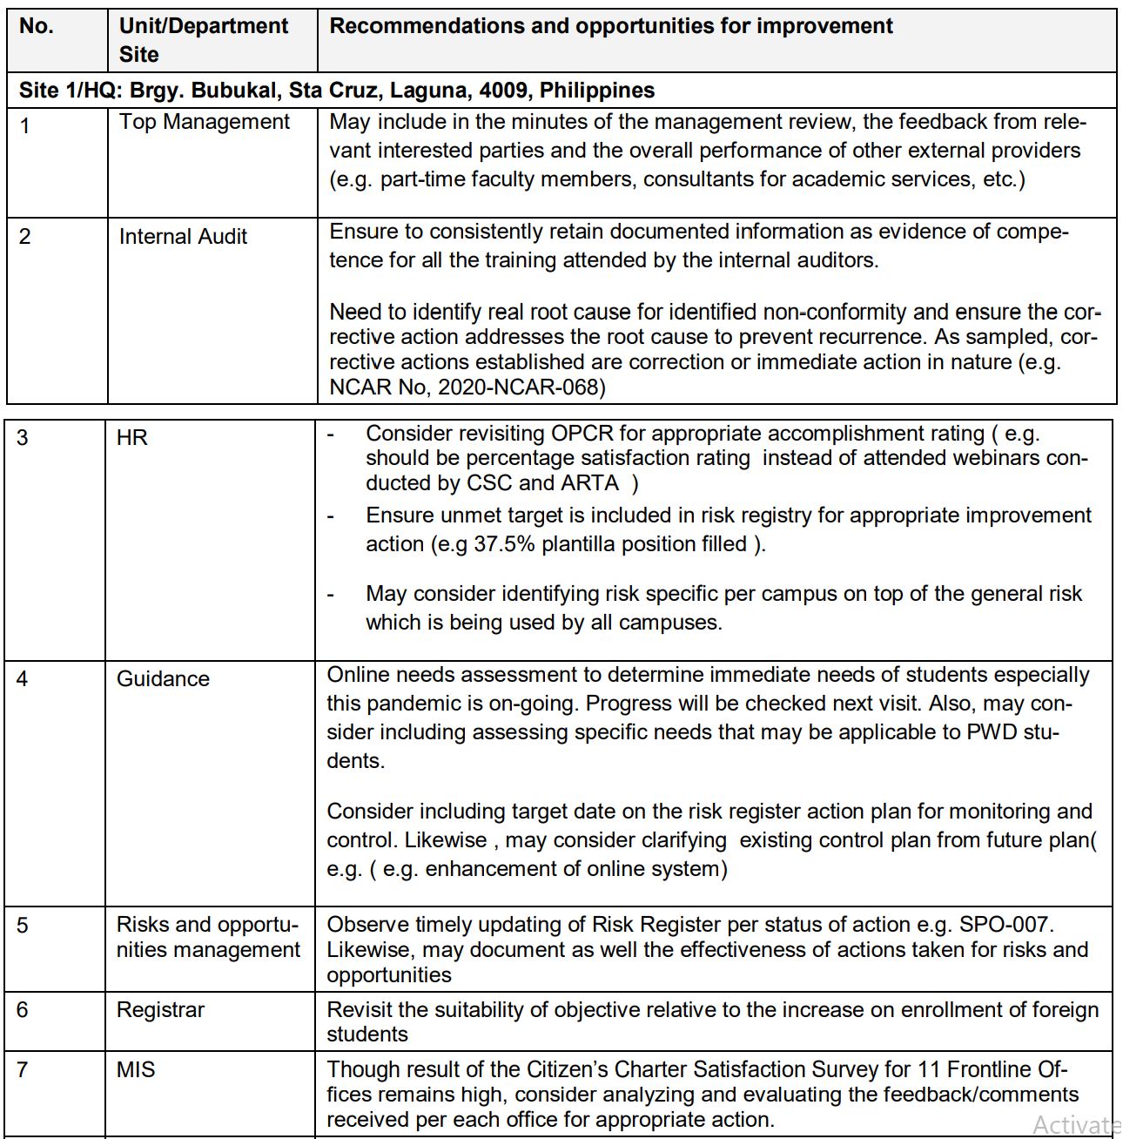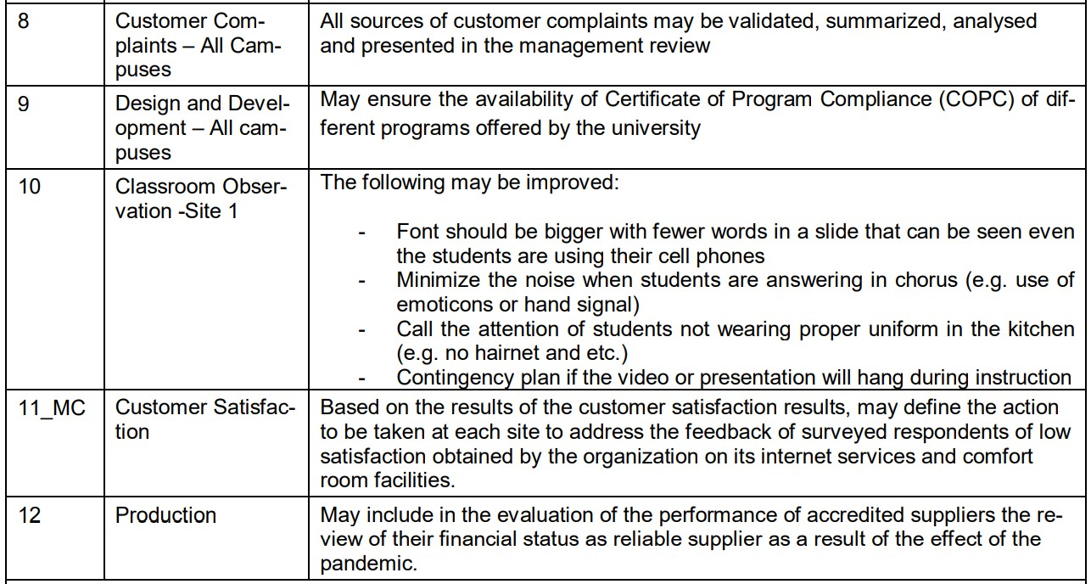

3

4

5

6

7 For the OFI, Dr. Yazon recommended that although some of the OFIs might

1. have been identified from a selected site only, it would be best for other process
2. owners to conduct their own self-assessment or auditing to determine if the
3. identified OFIs exists in their sites. He also emphasized that there is a note from the
4. document wherein it is stated that the items from OFIs may be visited, particularly
5. how the university took action for the specified OFI.
6. Finally, a minor non-conformity was found during the auditing. Quoted from
7. the presentation:
8. “The standard requires that the organization shall retain documented
9. information in applying controls to the design and development process to ensure
10. that reviews, verification and validation are conducted and evaluate the ability of the
11. results of design and development to meet the requirements. However, the
12. documented information for the review, verification and validation of the following
13. modules were not evident at the time of the audit:
14. 1. Mathematics of the Modern World
15. 2. Kitchen Essentials
16. Moreover, these learning contents were delivered to the students already.”

17

1. For the said minor non-conformity, Dr. Yazon shared that the university took
2. an immediate action for this. A meeting was conducted and the non-conformity form
3. was accomplished which was then submitted to TUVRheinland in November 2020.
4. The said report is comprised of a root cause analysis, corrective actions taken, and
5. evidences for the said actions. Upon submission of the said report, the LSPU was
6. granted the recommendation “maintenance of existing certification”, hence, re-
7. certification.

25

1. • *Review of the Learning Continuity Plan.* Upon the surveillance audit, Dr. Yazon shared
2. that they realized the need to review the crafted Learning Continuity Plan (LCP).
3. Specifically, this focuses on the quality assurance measures for the learning
4. materials.
5. Dr. Yazon informed the body that this coming semester, the university will
6. continue utilizing the self-paced learning modules (SLMs), one of the best practices of
7. the university. It is also one of the evidences for the approval of the Board for the LCP
8. and for CHED recognition for the university as one of the best higher education
9. institutions (HEIs) in the region. In line wit this, Dr. Yazon sought for the continued
10. cooperation of the members of the University Cluster Curriculum and Review
11. Committee (UCCRC) in the accomplishment of the SLMs. As pilot-tested from the
12. previous year, the recommendations from the implementers and end-users are to be
13. considered for improvement.

39

1. • *Activities and Timeline.* For the information and guidance of everyone, Dr. Yazon also
2. presented the timelines of activities that the members should take note of:

1

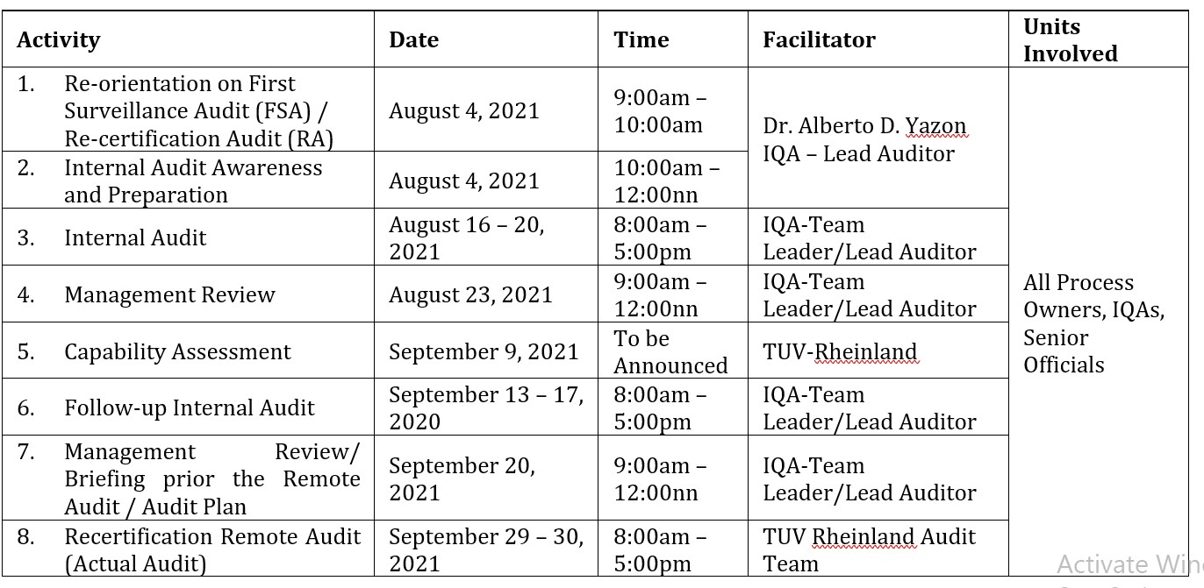

2

* 1. For preparations, the following documents were enumerated for filing for the
  2. auditing: Quality Manual; Procedure Manual; Work Instructions; OPCR (July to
  3. December, 2020 and January to June, 2021); University – wide Contingency Plan;
  4. Learning Continuity Plan; Unit – specific Contingency Plan (if any); Survey Results
  5. and Analysis (Minutes of the Meeting that shows that you evaluate and analyze the
  6. result of your Client Satisfaction Survey); Updated Risk Register; Records (latest
  7. revision) containing existing statutory and regulatory requirements that must be
  8. strictly followed (with legal, financial, institutional implications, etc. if violated) –
  9. date of issue may be earlier than Oct. 2020 e.g. BOR Resolution, OUP Policies. Interim
  10. Guidelines, CHEd Advisories, IATF/DOH Guidelines, etc.; Minutes of the Meeting (s)
  11. Please include the following: Minutes of the Meeting(s) for Review of Procedures
  12. Communication Letters (Internal/External); Office Memorandum (if any) issued
  13. either by your unit or by other units of LSPU that are related to your unit’s
  14. functions/operations/procedures/processes; Forms generated by your office/units
  15. (if any); Internal Guidelines (if any); Technical/Narrative Reports (if any); Important
  16. email correspondences (if any); Other Pertinent internal documents/records related
  17. to your unit’s daily operations or functions, procedures and/or processes; External
  18. documents/records that are necessary to your unit’s daily operations or functions,
  19. procedures and/or processes; and for offices/units with NCs and OFIs, a separate
  20. folder for the evidences that will prove that your action plans were implemented.

23

1. • *Clarifications and Concerns.* After the presentation, Dr. Yazon opened the virtual floor
2. for any questions, clarifications, and other relevant concerns.
3. 1. *Compliance to OFI.* Recognizing that there are new members, Mr. Cornelio R.
4. Molon requested for Dr. Yazon to reiterate the possible consequences should the
5. OFIs are not complied. To this, the latter explained that failure to address them
6. might result in non-conformity. The members were also encouraged to make
7. necessary preparations such as plan of actions for the identified OFIs.
8. 2. *Issuance of NCRs.* Engr. Raniel Louie W. Mendiola, the new team leader at the Sta.
9. Cruz Campus, inquired on the NCRs issued to the university. To this, Dr. Yazon
10. encouraged the process owners to design a plan of activities and make a narrative
11. report to be reviewed by the quality management review of the campus. This is a
12. recommendation he made in order to do away with the issuance of NCRs and
13. lessen the documentations.
14. Engr. Mendiola reiterated that in the previous audits, NCRs and OFIs were
15. appearing in the reports, hence, the inquiry for its issuance. However, Dr. Yazon
16. shared that from his understanding, NCRs are issued if there is a need for root
17. cause analysis and corrective actions needed to be verified by IQA or team
18. leaders.
19. Mr. Molon also explained that since it is the external auditing team,
20. TUVRheinland, that observed the OFIs, their recommendations become the basis
21. for the conduct of corrective actions. Dr. Yazon shared that it is the responsibility
22. of the university to comply with the OFIs; however, it is no longer the priority of
23. the external auditors to have the OFIs to be brought up. For OFI, there is no
24. evidence presented to the external auditors; only NCRs are provided with
25. evidences.
26. Dr. Rolando Cruzada shared that although OFIs are not the requirement of
27. external auditors, it should be directly addressed by the process owners;
28. otherwise, the recurrence of OFI might result in NCR, hence, the caution.
29. 3. As final note, Dr Yazon remined the body to consider a humanitarian approach in
30. the processing of auditing. He also shared the slides used for the presentation.
31. Upon hearing no other concerns, the meeting was adjourned. A separate
32. meeting succeeded among internal auditors.

21

22 XXX----------

23

1. I hereby attest that the foregoing minutes of the Internal Quality Auditors (Process Owners)
2. Meeting via Zoom Meet on August 4, 2021, which are contained in ten (10) pages, including
3. this page, are true and correct records of the proceedings of the Internal Quality Auditors
4. (Process Owners) meeting.

28

29



30 CERTIFIED TRUE AND CORRECT:

31

32

## ALBERTO D. YAZON, PhD

1. Director for Quality Assurance

35

36 ATTESTED:

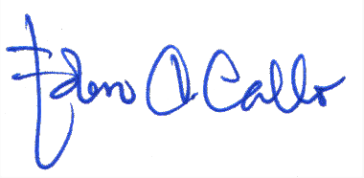

37

38

## EDEN C. CALLO, EdD

1. Vice President for Academic Affairs

## 1 INTERNAL QUALITY AUDITORS

2 **__________________________________________________________________________________________________________**

3

## MINUTES OF THE QUALITY MANAGEMENT REPRESENTATIVES (TOP MANAGEMENT),

1. **INTERNAL QUALITY AUDITORS, AND PROCESS OWNERS MEETING HELD VIA ZOOM ON**
2. **SEPTEMBER 3, 2021, 9:00 AM**

7 **__________________________________________________________________________________________________________**

8

## PRESENT

1. Top Management
2. *Vice President*
3. DR. EDEN C. CALLO Academic Affairs
4. ENGR. BELTRAN P. PEDRIGAL Administration
5. DR. ROBERT C. AGATEP Research and Development

15

1. *Campus Director*
2. ENGR. MANUEL LUIS ALVAREZ Sta. Cruz Campus
3. JOEL M. BAWICA Los Baños Campus

19

20 Internal Quality Auditors and Process Owners

21

22 *Academic Officials and Staff*

|  |  |  |
| --- | --- | --- |
| 23 |  | *Dean* |
| 24 | DR. EDITHA R. PEREY | College of Agriculture |
| 25 | DR. RICHARD C. AMPO | College of Arts and Sciences |
| 26 | DR. MARYJANE D. FUENTES | College of Business Management |
| 27 |  | and Accountancy |
| 28 | DR. JEFFERSON L. LERIOS | College of Computer Studies |
| 29 | ENGR. JONNEL K. PABICO | College of Engineering |
| 30 | JOSELITO S. MIRANDA | College of Fisheries |
| 31 | CHARMINE V. RIVERA | College of Hospitality Management |
| 32 |  | and Tourism |
| 33 | DR. FREDDIE S. PINUELA | College of Industrial Technology |
| 34 |  |  |
| 35 |  | *Associate Dean* |
| 36 |  | *College of Arts and Sciences* |
| 37 | DR. JULIE FE D. PANOY | San Pablo City Campus |
| 38 | JEROME S. NICOLAS | Los Baños Campus |
| 39 |  |  |
| 40 |  | *College of Business Management* |
| 41 |  | *and Accountancy* |
| 42 | GRACE M. ESMADE | Siniloan Campus |
| 43 | DR. DESIREE WAGAN | San Pablo City Campus |
| 44 |  |  |
| 45 |  | *College of Computer Studies* |
| 46 | REYNALEN JUSTO | Sta. Cruz Campus |
| 47 | ARCHIEVAL M. JAIN | Siniloan Campus |
| 48 | RONNEL A. DELA CRUZ | San Pablo City Campus |

|  |  |  |
| --- | --- | --- |
| 1 |  | |
| 2 |  | *College of Criminal Justice Education* |
| 3 | WILFREDO D. DALUGDOG | Siniloan Campus |
| 4 |  |  |
| 5 |  | *College of Engineering* |
| 6 | ENGR. MENCHIE DEL ROSARIO | Siniloan Campus |
| 7 | ENGR. PAUL ENRICO F. PUYO | San Pablo City Campus |
| 8 |  |  |
| 9 |  | *College of Food Nutrition and Dietetics* |
| 10 | DR. ERICA B. TABUAC | Los Baños Campus |
| 11 |  |  |
| 12 |  | *College of Hospitality Management* |
| 13 |  | *and Tourism* |
| 14 | DR. NINEVETCH GRACE O. MARCO | San Pablo City Campus |
| 15 |  |  |
| 16 |  | *College of Industrial Technology* |
| 17 | EUDORA C. TABO | San Pablo City Campus |
| 18 |  |  |
| 19 |  | *College of Teacher Education* |
| 20 | DR. EDILBERTO Z. ANDAL | San Pablo City Campus |
| 21 | DR. KAREN MANAIG | Los Baños Campus |
| 22 |  |  |
| 23 | *Administrative Officials and Staff* |  |
| 24 |  | *Director* |
| 25 | MARY GRACE P. GALLARDO | Alumni and Placement Services |
| 26 | MARIE AMMABELLE I. CABILDO | Budget and Finance Services |
| 27 | DR. RUBY B. BRION | Gender and Development |
| 28 | EDWARD S. FLORES | Information and Communication |
| 29 |  | Technology Services |
| 30 | MARIA LIRIO C. RAGEL | Human Resource Management |
| 31 | HOSEAL B. GAYMAN | Library Services |
| 32 | ENGR. RANIEL LOUIE W. MENDIOLA | Management Information System |
| 33 | DR. ALBERTO D. YAZON | Quality Assurance |
| 34 | JAYSON N. OLAYTA | Student Affairs Services |
| 35 |  |  |
| 36 |  | *Chairperson* |
| 37 |  | *Admission and Registrarship* |
| 38 | EVELYN B. NAPIZA | Sta. Cruz Campus |
| 39 | MA. GRACIELLA C. PRADILLADA | Siniloan Campus |
| 40 |  |  |
| 41 |  | *Alumni Affairs and Placement Services* |
| 42 | JENNELYN E. ESPINUEVA | San Pablo City Campus |
| 43 |  |  |
| 44 |  |  |
| 45 |  | *Business Affairs Office* |
| 46 | ROWENA A. NAGA | Sta. Cruz Campus |
| 47 |  |  |
| 48 |  |  |

|  |  |  |
| --- | --- | --- |
| 1 |  | *Curriculum and Instruction* |
| 2 |  | *and Development* |
| 3 | DR. VILMA M. GERONIMO | Sta. Cruz Campus |
| 4 |  |  |
| 5 |  | *Extension and Training Services* |
| 6 | AIMEE CONCEPCION CHAVEZ | Siniloan Campus |
| 7 | RACHELLE C. GALLANO | Los Baños Campus |
| 8 |  |  |
| 9 |  | *Guidance Services* |
| 10 | ABIGAIL O. VIAR | Sta. Cruz Campus |
| 11 | NOEMI B. NUÑES | Los Baños Campus |
| 12 |  |  |
| 13 |  | *Human Resource Management* |
| 14 | ANNALIZA B. DE ROMA | San Pablo City Campus |
| 15 | EFREN R. DELA PAZ, JD | Los Baños Campus |
| 16 |  |  |
| 17 |  | *Information and Communications* |
| 18 |  | *Technology Services* |
| 19 | NEIRRO C. ILAGAN | San Pablo City Campus |
| 20 | LOYD S. ECHALAR | Los Baños Campus |
| 21 |  |  |
| 22 |  | *International and Local Affairs* |
| 23 | CELESTE C. MARQUEZ | Sta. Cruz Campus |
| 24 | CHESTER DEREQUITO | San Pablo City Campus |
| 25 |  |  |
| 26 |  | *Library Services* |
| 27 | MARIA NINA GRACE C. PASTORFIDE | San Pablo City Campus |
| 28 |  |  |
| 29 |  | *Planning and Development* |
| 30 | ENGR. MARICEL M. MATUTO | Sta. Cruz Campus |
| 31 |  |  |
| 32 |  | *Physical Plant and Site Development* |
| 33 | WILFREDO G. TUSO, III | Siniloan Campus |
| 34 | CRISTOPHER M. MENDOZA | Los Baños Campus |
| 35 |  |  |
| 36 |  | *Quality Assurance* |
| 37 | DR. ENRICO R. RIVANO | Sta. Cruz Campus |
| 38 | ENGR. ROMMEL OCTAVIUS R. NUESTRO | Siniloan Campus |
| 39 | LORENA H. GARCIA | San Pablo City Campus |
| 40 |  |  |
| 41 |  | *Research and Development* |
| 42 | DR. DELON A. CHING | San Pablo City Campus |
| 43 | OFELIA B. MANINGAS | Los Baños Campus |
| 44 |  |  |
| 45 |  | *Scholarship and Financial Assistance* |
| 46 | DR. AGRIPINA F. BANAYO | San Pablo City Campus |
| 47 | FLORA H. SALANDANAN | Los Baños Campus |
| 48 |  |  |

|  |  |  |
| --- | --- | --- |
| 1 |  | *Senior High School* |
| 2 | DR. RAY SAMUEL G. GRECALDA | Sta. Cruz Campus |
| 3 |  |  |
| 4 |  | *Sports Development* |
| 5 | DR. LIZA L. BARTOLOME | Sta. Cruz Campus |
| 6 |  |  |
| 7 |  | *Student Affairs and Services* |
| 8 | ALBERTO B. CASTILLO | San Pablo City Campus |
| 9 |  |  |
| 10 |  | *Coordinator* |
| 11 | DR. VICTORIA E. TAMBAN | Innovation and Technology Support Office |
| 12 |  |  |
| 13 | CHRISTIAN A. CALABIA | Administrative Aide V |
| 14 | SIEGFRIED S. CRUCILLO | University Nurse |
| 15 |  |  |
| 16 | *Internal Quality Auditors* |  |
| 17 | ENGR. TERESITA F. BUENO | Siniloan Campus |
| 18 | CORNELIO R. MOLON | Siniloan Campus |
| 19 | FLAVIANO URERA JR. | Siniloan Campus |
| 20 | MERCY GRACE I. SALIENDRA | Siniloan Campus |
| 21 | MARCO DEL ROSARIO JR. | San Pablo City Campus |
| 22 | CATHERINE A. CASTILLO | San Pablo City Campus |
| 23 | LIVIEN U. CIABAL | San Pablo City Campus |
| 24 | FLOREIZL P. VENTOCILLA | San Pablo City Campus |
| 25 | GLEN P. CORTEZANO | Los Baños Campus |
| 26 | MARGARITA A. GALANG | Los Baños Campus |
| 27 | ROSEMARIE A. MALAPAYA | Los Baños Campus |
| 28 | KRISTELLE ANN R. TORRES | Los Baños Campus |
| 29 |  |  |
| 30 | *Process Owners* |  |
| 31 | BRAINARD H. REYES | Sta. Cruz Campus |
| 32 | CLAUDETTE LUI M. REYES | Sta. Cruz Campus |
| 33 | MA. CECILIA C. GATBONTON | Siniloan Campus |
| 34 | LARA JANE R. IMPERIAL | San Pablo City Campus |
| 35 | ANA DIGI FRANCISCO MERAÑA | San Pablo City Campus |
| 36 | ELENOR C. TAN | San Pablo City Campus |
| 37 | MAY P. BELARMINO | Los Baños Campus |
| 38 | MYRNA O. MEDRANO | Los Baños Campus |
| 39 | RICARDO F. WAGAN III | Los Baños Campus |
| 40 |  |  |
| 41 | KEVIN A. AMANTE | Staff, Office of the Vice President |
| 42 |  | for Academic Affairs |
| 43 | IVAN CRISS R. CATAÑEDA | Staff, CBMA-Sta. Cruz Campus |
| 44 | JOHN CARLO A. PANGILINAN | Staff, CCS-Sta. Cruz Campus |
| 45 | SHANEE MAY R. GONZALES | Staff, PPSD-Siniloan Campus |
| 46 | SHARON S. BANDERLIPE | Staff, CONAH-Sta. Cruz Campus |

1. x x
2. The following accounts are the minutes of the meeting:

1

## A. PRELIMENARIES

* 1. *Rationale:* Mrs. Glen P. Cortezano, Internal Quality Auditor at the Los Baños Campus,
  2. who served as the moderator of the meeting, called in Dr. Alberto D. Yazon, Director
  3. for Quality Assurance, for the rationale of the meeting. Upon greeting all the
  4. attendees, Dr. Yazon presented the overview of the meeting, the objective of the
  5. meeting, ISO general framework, and the seven (7) principles of management system
  6. auditing.

9

1. *Agenda of the Meeting:* Putting the meeting into order, Dr. Yazon presented the
2. agenda for the meeting, to wit:
3. • presentation and Approval of the minutes of the previous meeting;
4. • rescheduled ISO Activities and Timeline;
5. • updating of Risk Register;
6. • updating of Office Performance Commitment and Review (OPCR); and
7. • remote Internal Audit Plan.

17

## B. PRESENTATION AND APPROVAL OF AGENDA

1. **1. Presentation and Approval of the Minutes of the Previous Meeting**
2. Dr. Yazon presented to the body the minutes of the meeting held on August 4,
3. 2021, via Zoom. The agenda presented during the meeting included: ISO 2nd
4. Follow Up Remote Audit Report; Review of LSPU LCP; Activities and Timeline,
5. and ISO Recertification Preparation. After the presentation, Mrs. Cortezano called
6. for any comments and corrections. Hearing no feedback, Engr. Rommel Octavius
7. R. Nuestro, Chairperson for Quality Assurance at the Siniloan Campus, moved for
8. the approval of the minutes of the previous meeting, duly seconded.

## APPROVED

28

## 2. Rescheduled ISO Activities and Timeline

1. Dr. Yazon presented the final schedule to the body, for the members to be
2. informed of the plan the university has concerning auditing activities.

32 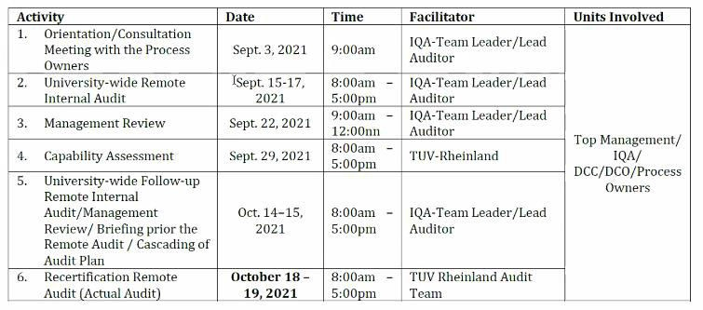

1. Dr. Yazon also noted the possibility of the auditing to be conducted for one (1)
2. day only, similar to what happened last year, depending on the auditing team.

## PRESENTED

1

* 1. *University-wide Internal Auditing.* Before proceeding to the next agendum, Mr.
  2. Cornelio R. Molon, Internal Quality Auditor at the Siniloan Campus, asked Dr.
  3. Yazon to share to the body the decision the internal quality auditors (IQA) came
  4. up with during a separate meeting, since the decision they came up with will be
  5. affecting everybody in the conduct of the auditing. To this, Dr. Yazon informed the
  6. body that the team leaders and IQAs agreed that the system of the remote audit
  7. will be university-wide. The units will meet in a single room where there will be
  8. four or five auditors from different campuses to perform remote auditing. Such a
  9. practice could be regarded as one of the best practices of the university. After
  10. finding out some incongruities in the practices among sites (i.e., an area as a
  11. minor non-conformity in one campus perceived as having best practice in another
  12. site); hence, there was a need to have an alignment of processes.

## PRESENTED

15

## 3. Updating of Risk Register

1. Engr. Raniel Louie W. Mendiola, Team Leader for the Sta. Cruz Campus,
2. provided a re-orientation on risk register, referring to the reports on file which
3. were submitted last year. Engr. Mendiola reminded the body that the risk register
4. is a running document, hence, the need to update from time to time. As an
5. example, he used the risk register report of the Management Information System
6. (MIS), specifying the template units (cells).
7. He also reminded the attendees that it is important for the external auditors
8. (i.e., TUVRheinland) to see that the university is monitoring the risk assessment
9. reports. Hence, the risk register report per unit, which shall be common among
10. campuses, must be available should it be asked for a review by the auditors.
11. After the presentation, Ms. Marie Ammabelle I. Cabildo, Director for Budget
12. and Finance Services, clarified the status/remark in the risk register should the
13. risk for a unit be addressed in two campuses yet not yet for the remaining
14. campuses. Specifically, Ms. Cabildo was referring to the reminder Engr. Mendiola
15. mentioned earlier that the risk report for a unit shall be the same for all
16. campuses. To this, Engr. Mendiola suggested that in such a case, the campuses
17. which had already addressed the concern may share the plan they implemented
18. with the remaining campuses. He emphasized that the risk register is system-
19. wide, hence, the risk should be resolved among all campuses for a unit.
20. Dr. Richard C. Ampo, Dean for the College of Arts and Sciences (CAS), asked
21. Engr. Mendiola for a copy of the risk register reports. To this, Engr. Mendiola
22. settled to send a copy of the report to a specific person per office/unit.
23. For technical clarity, Engr. Mendiola asked Dr. Yazon if the records of the two
24. offices Curriculum and Instruction Development (CID) and Quality Assurance
25. (QA), formerly a single unit, would be separated or remain as one. To this, Dr.
26. Yazon said that the report will retain its status as a combined report for the time
27. being.
28. Referring to the risk register report for the academics, Dr. Eden C. Callo, Vice
29. President for Academic Affairs, asked what the remarks would be for a risk that is
30. due in December 2021. Engr. Mendiola confirmed that it will still be open; should
31. a risk remain open beyond the indicated date for resolution, the plan for action
32. may be updated. Dr. Yazon also added that the remarks for the opportunity
33. assessment may be changed from "accept" to "share" since there are colleges that
34. contributed to the improvement of the program through Certificate of Program
35. Compliance (COPC) and other compliance reports (e.g., accreditation).
36. Engr. Mendiola reminded the body that the reports and updates should be
37. finalized by the concerned individuals/owners before sending to him for record-
38. keeping.

## NOTED

8

## 9 4. Updating of the Office Performance Commitment and Review (OPCR)

1. Engr. Mendiola presented the Office Performance Commitment and Review
2. (OPCR), stressing its importance as a record to be shown to the auditors since it
3. contains the targets and accomplishments of the office/unit. As an example, Engr.
4. Mendiola referred to the OPCR of the Management Information System (MIS),
5. specifying its content and how to go about it.
6. Engr. Mendiola also noted the changes that will transpire with the approval of
7. the new strategic plan and its changed strategic objectives, aligning the OPCR
8. with the new objectives.
9. *LSPU Strategic Plan 2020-2024.* Dr. Adriel G. Roman, Director for Planning and
10. Development, continued the presentation, picking up on the concern raised by
11. Engr. Mendiola on the alignment of the OPCR with the new strategic objectives.
12. Dr. Roman shared that, to his understanding, the university will be audited based
13. on its current and previous status, whereas the approval of the strategic plan was
14. on July 2021 only.
15. Dr. Roman proceeded with a brief presentation of the LSPU Strategic Plan
16. 2020-2024, detailing the salient activities such as the seminar workshop,
17. presentation to the councils, recommendations of the board, consultation with
18. the regional director, until reaching approval.
19. Going back to the concern raised earlier, a meeting/consultation will be
20. scheduled for the recalibration of the OPCR with the new strategic objectives.
21. *Clientele Satisfaction Survey.* Mr. Jayzon N. Olayta, Director for Student Affairs
22. and Services (SAS), raised his concern on the OPCR for SAS. He informed the body
23. on the plan of SAS to revise the existing OPCR of SAS since it is not aligned with
24. the strategic plan and new CMO for SAS. To this, Dr. Roman concurred with the
25. need for revision; however, it should go with observance to the time frame.
26. Mr. Olyata also raised the concern on the updating of the content of the
27. clientele satisfaction, especially since the applicability of ratings refers to a face-
28. to-face situation and not on the online setting. Mr. Olayta shared the low rating
29. they gathered with the justification of the students (end-users) not knowing if the
30. facilities they were asked to rate have already improved, hence, the poor rating.
31. To this, Engr. Mendiola suggested the use of the option “Not Applicable” or “NA”.
32. He also noted that the ISO forms can be revised by the head of the unit. This was
33. backed up by Mr. Hoseal Gayman, Director for Library Services and former Lead
34. Auditor, clarifying that the content (e.g., questions asked) is not being controlled
35. for ISO, so long as it is reviewed and approved by the head of the unit. Mr.
36. Gayman reiterated that what is important to the auditors is that the forms are
37. reviewed and approved before implementation. In addition to what Engr.
38. Mendiola and Mr. Gayman said, Mr. Molon reminded Mr. Olayta to conduct
39. consultation with chairpersons and have the proceedings of the consultation
40. recorded, keeping the minutes of the meeting for filing and reference.
41. Ms. Cabildo clarified the evaluator/signatories for the OPCR. Engr. Mendiola
42. explained that the OPCR of a unit is to be evaluated by the campus director where
43. the unit is situated/housed. The director for the unit/office should have a
44. consolidated copy of the OPCR for the unit/office. Mr. Gayman explained that for
45. directors, there will be two (2) preparations to take note of, one is the four OPCR
46. for each campus and one for a consolidated OPCR for the unit.
47. *OPCR Rating.* Ms. Cabildo also clarified for the rating to be given, specifically
48. the maximum point to be given. To this, Dr. Roman explained that a rating of five
49. (5) can be given should the specific items be satisfied, with a special note on the
50. part for the budget. In connection to this, A/Prof. Joel Bawica, Campus Director
51. for the Los Baños Campus, inquired if the rating to be given should be a whole
52. number, observing units/offices using ratings with decimal points (e.g., 4.2., 4.7).
53. Although it is the Campus Director that should be doing the rating, there has been
54. a practice in other campuses wherein self-assessment is being practiced.
55. Going back to the concern of Mr. Olayta, Mr. Edward S. Flores, Director for
56. Information and Communications Technology Services (ICTS), shared that there
57. is an in-house-developed program for the form. Should there be changes in the
58. form, Mr. Flores asked the body to let them know to update the system.
59. A/Prof. Sandra P. Mesina, Chairperson for International and Local Affairs
60. (ILA) at Siniloan Campus, raised her concern regarding their unit, specifically on
61. the number of students for in-bound and out-bound. A/Prof. Mesina asked if they
62. still need to include the numerical targets in the form, specifically July to
63. December, given the limitation of the condition due to the pandemic. To this,
64. Engr. Mendiola suggested indicating zero (0) for accomplishment since it is not
65. feasible brought about by the pandemic. On the interventions sought by A/Prof.
66. Mesina, Engr. Mendiola suggested that this concern be indicated in the risk
67. register.
68. Going back to the unsettled concerns, Dr. Roman suggested resolving the
69. concern for uniformity, which CD Bawica suggested to be moved into a motion.
70. Dr. Roman put the concern into motion, seconded to the body. However,
71. clarifications were raised regarding it.
72. On the clarification asked by Ms. Cabildo, Mr. Gayman explained that the use
73. of whole number rating shall be used for individual cells (Quality, Efficiency,
74. Timeliness, Average: QETA); however, for the average rating wherein the result is
75. likely to have decimal points, the results shall be as is.
76. Dr. Victoria E. Tamban, Chairperson for Innovation and Technology Support
77. Office (ITSO) at the Los Baños Campus, shared that, as Dr. Roman stated, the
78. whole number shall be used since there is no rating in the decimal point indicated
79. in the form.
80. Before proceeding with the next concern, Mr. Molon asked the body to put the
81. pending concern into motion as it was not formally approved, hence, a call for
82. voting. Votes were cast online, gathered by Mrs. Cortezano. Having gathered the
83. majority of the votes, the motion was approved:

45

46

47

48

## INTERNAL QUALITY AUDITORS RESOLUTION 001

* 1. **Series of 2021**

3

## 4 UNIFORM NUMERICAL RATING PRACTICE FOR IPCR AND OPCR

5

1. BE IT RESOLVED AS IT IS HEREBY RESOLVED THAT THE RATING IN THE CELLS
2. FOR THE QUALITY, EFFICIENCY, TIMELINESS, AND AVERAGE (QETA) OF THE
3. OFFICE PERFORMANCE COMMITTEE REVIEW (OPCR) AND INDIVIDUAL
4. PERFORMANCE COMMITTEE REVIEW (IPCR) SHALL USE WHOLE NUMBERS
5. ONLY (I.E., NO DECIMAL RATING)

## APPROVED

12

1. *Self-Assessment for OPCR and IPCR.* Going back to other concerns on OPCR and
2. IPCR, Dr. Roman shared that local and university-wide management teams have
3. been created which are responsible for the reviewing and updating of the OPCR
4. and IPCR. Specifically, Dr. Roman expressed the need to do away with self-rating
5. and the desire to put it into motion. Having no comments received from the body,
6. Dr. Roman put the concern into motion, duly favored by the majority:

19

## INTERNAL QUALITY AUDITORS RESOLUTION 002

1. **Series of 2021**

22

## 23 NON-ISSUANCE OF SELF-RATING FOR IPCR AND OPCR

24

1. BE IT RESOLVED AS IT IS HEREBY RESOLVED THAT THERE SHALL BE NO SELF-
2. RATING TO BE ISSUED FOR OFFICE PERFORMANCE COMMITTEE REVIEW
3. (OPCR) AND INDIVIDUAL PERFORMANCE COMMITTEE REVIEW (IPCR) AMONG
4. ALL UNITS AND ACROSS CAMPUSES OF THE UNIVERSITY

29

1. PROVIDED, THAT THE PERFORMANCE MANAGEMENT TEAMS, BOTH THE
2. LOCAL AND UNIVERSITY-WIDE, SHALL BE RESPONSIBLE TO ACCOMPLISH THE
3. OPCR AND IPCR

## APPROVED

34

1. *Revision of the OPCR and IPCR.*Covering all the matters relative to the OPCR and
2. IPCR, Dr. Roman also raised the concern on the rating relative to the Likert scale.
3. Dr. Roman suggested the use of a standard range/scale to be referred to for a
4. more considerate rating. As clarified by CD Joel, this will only be used for the final
5. rating.
6. In connection to this, Mr. Gayman asked if Dr. Roman has a proposed scale to

41 which the latter shared to the body: 4.50-5.00, 3.50-4.49, 2.50-3.49, 1.50-2.49,

1. and 1.00-1.49, with the following adjectival rating of “Outstanding”, “Very
2. Satisfactory”, “Satisfactory”, “Fairly Satisfactory”, and “Poor”.
3. Wilfredo D. Dalugdog, Associate Dean for the College of Criminal Justice
4. Education (CCJE) at Siniloan Campus, shared that there is a clear explanation on
5. the use of the Strategic Performance Management System (SPMS) from the Civil
6. Service Commission (CSC), as per MC No. 6, 2012. To this, Dr. Roman shared that
7. the said CSC memo was also referred to as the basis for the university
8. OPCR/IPCR. Dr. Agripina F. Banayo, Chairperson for Scholarship and Financial
9. Assistance at the San Pablo City Campus, suggested the use of the rules of
10. rounding numbers.
11. Dr. Robert C. Agatep, Vice President for Research and Development, inquired
12. on the appropriateness of the body to craft an enhanced instrument; that is,
13. concerning what Mr. Dalugdog shared, Dr. Agatep was clarifying if the university
14. should follow the one issued from the CSC or the institution is allowed to craft its
15. own, subject to specific criteria and guidelines from the said CSC memo. To this,
16. Maria Lirio C. Ragel, Director for Human Resource Management Office (HRMO),
17. explained that although CSC released guidelines, the institution can create its
18. own, so long as it does not veer away from the existing principle of CSC. In line
19. with this, Dr. Callo and Engr. Beltran P. Pedrigal, Vice President for
20. Administration, supported the idea of the institution crafting its own instrument.
21. Engr. Pedrigal added that the Performance Management Team (PMT) of the
22. institution will hold a meeting for the crafting of the instrument to be approved
23. by the University President. Dr. Agatep pointed out that what Engr. Pedrigal said
24. answered his query on the legitimate body to craft the instrument. Adding to this,
25. Mr. Molon explained that the process done for the crafting of the instrument is a
26. good practice should the auditing team require records and evidence of the
27. process that transpired in the crafting of the instrument.
28. Supporting the concerns raised by Dr. Roman, Dr. Yazon moved for the
29. adoption of the proposed rating scale as the basis of the PMT for the crafting of
30. the performance assessment instrument. Mr. Gayman suggested that the motion
31. be made is the revision of the performance management system.
32. Dr. Roman also requested for the noting of the urgency of the concern, hence,
33. the need for immediate action. Mr. Gayman also reiterated the request for the
34. changes to be evident by the time the next management review will be conducted.
35. In line with this, Engr. Pedrigal, as the head of the PMT, stated that the conduct of
36. the PMT meeting will be next week to resolve the concerns raised; this was
37. supported by CD Bawica for the local PMT to conduct their meeting for
38. suggestions.

## NOTED

33

1. Engr. Mendiola asked if there is a need to have a presentation of the IPCR and
2. called for any concern about it. For the discussion of the OPCR and IPCR, Dr.
3. Roman requested their presentation in a separate meeting.

## NOTED

38

## 5. Remote Internal Audit Plan

1. Dr. Yazon provided a quick review of the proceedings of the meeting, namely,
2. the updating of the risk register, the preparation of the OPCR and IPCR, and the
3. updating of the impact assessment (i.e., satisfaction survey). Dr. Yazon went on
4. with the discussion of the auditing objectives, cycle, process (as defined in ISO
5. 19011:2018), characterization, players, evidence, evaluation, criteria, findings,
6. and conclusions.
7. Dr. Yazon also presented the Remote Audit Plan:

1

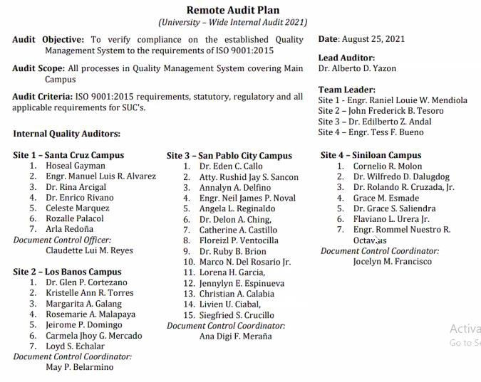

2

## 3 Date of Internal Audit: September 15 – 17, 2021

4

|  |  |  |  |  |  |
| --- | --- | --- | --- | --- | --- |
| Common clauses: | | 4.4; 6.1.1; 6.1.2; 6.2; 6.3; 7.4; 7.5; 9.1.2;  7.2; 7.3; 5.3; 9.1.3; 5.2.2; 8.5.2; 8.5.6; 10.2; 10.3 | | | |
| **Date** | **Time** | **Areas/Processes** (for all 4 campuses covering  Site 1, 2, 3 & 4) | **Standard Chapter** | **Auditee/ Room** | **Auditor/ Room** |
| **Day 1 – AM** | | | | | |
| Sept. 15,  2021 | 8:00-8:30 | All | Opening Meeting | All (Main Room) | All (Main Room) |
| Sept. 15,  2021 | 8:30-9:30 | Top Management | 4.1, 4.2, 4.3, 5.1, 5.2, 5.3,  6.1,6.2,  6.3. 7.1,7.4, 9.1,9.2,9.3, 10.1,  10.2, 10.3 | CDs/VPs (Main Room) | H. Gayman  A. Yazon  R. Malapaya  R. Brion  E. Andal  C. Molon (Main Room) |
| Sept. 15,  2021 | 9:30-11:30 | Academic Heads / Curriculum Design and Development / NSTP | 6.1, 6.2, 6.3. 7.1.2, 7.1.3, 7.1.4,  7.1.5, 7.1,6,  8.1, 8.2.3, 8.3.5, 8.3.6, 8.5.1,  8.5.2, 8.5.3, 8.5.4,  8.5.5, 8.5.6, 8.6, 8.7, 9.1.1,  9.1.2,  9.1.3. 10.1, 10.2, 10.3 | Deans/ Associate Deans/CID  /QA (Room 1) | R. Mendiola  J. Tesoro  S. Crucillo  G. Saliendra (Room 1) |

|  |  |  |  |  |  |
| --- | --- | --- | --- | --- | --- |
| Sept. 15,  2021 | 9:30-11:30 | Research and ITSO | 6.1, 6.2, 6.3 ,7.1.2, 7.1.3, 7.1.4,  7.1.5, 7.1,6,  8.1, 8.2.3, 8.3.5, 8.3.6, 8.5.1,  8.5.2, 8.5.3, 8.5.4,  8.5.5, 8.5.6, 8.6, 8.7, 9.1.1,  9.1.2,  9.1.3,10.1,  10.2, 10.3 | Director/ Chairperso ns  (Room 2) | 1. Galang 2. Noval   J. Espinueva  R. Cruzada (Room 2) |
| Sept. 15,  2021 | 9:30-11:30 | Extension includingGAD | 6.1, 6.2, 6.3 ,7.1.2, 7.1.3, 7.1.4, | Director/ | M. del Rosario |
| 7.1.5, 7.1,6, |
| 8.1, 8.2.3, 8.3.5, 8.3.6, 8.5.1, | C. Mercado |
| 8.5.2, 8.5.3, 8.5.4,  8.5.5, 8.5.6, 8.6, 8.7.9.1.1, | Chairperso ns | L. Ciabal  F. Urera |
| 9.1.2, | (Room 3) | T. Bueno |
| 9.1.3,10.1, | (Room 3) |
| 10.2, 10.3 |
| Sept. 15,  2021 | 9:30-11:30 | Production/BAO | 6.1, 6.2, 6.3 ,7.1.2, 7.1.3, 7.1.4,  7.1.5, 7.1,6,  8.1, 8.2.3, 8.3.5, 8.3.6, 8.5.1,  8.5.2, 8.5.3, 8.5.4,  8.5.5, 8.5.6, 8.6, 8.7, 9.1.1,  9.1.2,  9.1.3,10.1,  10.2, 10.3 | BAO  Director/ Chairperso ns  (Room 4) | C. Marquez  S. Sancon  L. Echalar  C. Calabia (Room 4) |
| **Day 1 – PM** | | | | | |
| Sept. 15,  2021 | Sept. 15,  2021 | Sept. 15, 2021 | Sept. 15, 2021 | Sept. 15,  2021 | Sept. 15,  2021 |
| Sept. 15,  2021 | Sept. 15,  2021 | Sept. 15, 2021 | Sept. 15, 2021 | Sept. 15,  2021 | Sept. 15,  2021 |
| Sept. 15,  2021 | Sept. 15,  2021 | Sept. 15, 2021 | Sept. 15, 2021 | Sept. 15,  2021 | Sept. 15,  2021 |
| Sept. 15,  2021 | Sept. 15,  2021 | Sept. 15, 2021 | Sept. 15, 2021 | Sept. 15,  2021 | Sept. 15,  2021 |
| Sept. 15,  2021 | Sept. 15,  2021 | Sept. 15, 2021 | Sept. 15, 2021 | Sept. 15,  2021 | Sept. 15,  2021 |
| **DAY 2 – AM** | | | | | |
| Sept. 16,  2021 | Sept. 16,  2021 | Sept. 16,  2021 | Sept. 16, 2021 | Sept. 16,  2021 | Sept. 16,  2021 |
| Sept. 16,  2021 | Sept. 16,  2021 | Sept. 16,  2021 | Sept. 16, 2021 | Sept. 16,  2021 | Sept. 16,  2021 |
| Sept. 16,  2021 | Sept. 16,  2021 | Sept. 16,  2021 | Sept. 16, 2021 | Sept. 16,  2021 | Sept. 16,  2021 |
| Sept. 16,  2021 | Sept. 16,  2021 | Sept. 16,  2021 | Sept. 16, 2021 | Sept. 16,  2021 | Sept. 16,  2021 |
| Sept. 16,  2021 | Sept. 16,  2021 | Sept. 16,  2021 | Sept. 16, 2021 | Sept. 16,  2021 | Sept. 16,  2021 |
| **Day 2 – PM** | | | | | |
| Sept. 16,  2021 | Sept. 16,  2021 | Sept. 16,  2021 | Sept. 16, 2021 | Sept. 16,  2021 | Sept. 16,  2021 |
| Sept. 16,  2021 | Sept. 16,  2021 | Sept. 16,  2021 | Sept. 16, 2021 | Sept. 16,  2021 | Sept. 16,  2021 |
| Sept. 16,  2021 | Sept. 16,  2021 | Sept. 16,  2021 | Sept. 16, 2021 | Sept. 16,  2021 | Sept. 16,  2021 |
| Sept. 16,  2021 | Sept. 16,  2021 | Sept. 16,  2021 | Sept. 16, 2021 | Sept. 16,  2021 | Sept. 16,  2021 |
| Sept. 16,  2021 | Sept. 16,  2021 | Sept. 16,  2021 | Sept. 16, 2021 | Sept. 16,  2021 | Sept. 16,  2021 |

|  |  |  |  |  |  |
| --- | --- | --- | --- | --- | --- |
| **Day 3 – AM** | | | | | |
| Sept. 17,  2021 | Sept. 17,  2021 | Sept. 17, 2021 | Sept. 17, 2021 | Sept. 17, 2021 |  |
| **Day 3 – PM** | | | | | |
| Sept. 17,  2021 | Sept. 17,  2021 | Sept. 17, 2021 | Sept. 17, 2021 | Sept. 17, 2021 |  |
| **End of Audit** | | | | | |
| Oct.14-15 | Oct.14-15 | Oct.14-15 | Oct.14-15 | Oct.14-15 |  |

1

1. Dr. Yazon reiterated that the practice of university-wide internal auditing is
2. seen to assure that all units among all campuses are practicing the same
3. processes.

## NOTED

6

7

8 XXX----------

9

1. I hereby attest that the foregoing minutes of the Internal Quality Auditors Meeting via Zoom
2. on September 3, 2021, which are contained in fourteen (14) pages, including this page, are
3. true and correct records of the proceedings of the Internal Quality Auditors meeting.

13

14



15 CERTIFIED TRUE AND CORRECT:

16

17

## ALBERTO D. YAZON, PhD

1. Director for Quality Assurance
2. LSPU IQA Lead Auditor

21

22 ATTESTED:

23



24

## EDEN C. CALLO, EdD

1. Vice President for Academic Affairs